Assignment – 10
- 1st Command -> less
┌──(kumya㉿sonic)-[~]
└─$ less

(1) What is the less command? (History, invention, author)
The less command is a terminal pager program used in Unix/Linux to view text files one screen at a time with forward and backward navigation.
History & Origin
- The less command was written in 1983.
- Author: Mark Nudelman, a software engineer.
- It was created as an improvement over the older more command.
- The name "less" is a joke on the phrase "less is more" because less can do much more than more.
Purpose
To allow users to:
- Scroll both forward and backward
- Search within the file
- View large files without opening them in an editor
It does not load the complete file into memory, which makes it ideal for viewing VERY large log files.

(2) Why is the less command useful for System Administrators?
System administrators frequently work with:
- Log files (/var/log/syslog, /var/log/auth.log)
- Configuration files
- Shell outputs
- Large data files
less becomes essential because it allows:
Reasons for Use
- Fast viewing of large files without opening an editor
- Forward and backward scrolling (unlike more)
- Pattern searching using /searchterm
- Efficient memory usage
- Pipe support: ps aux | less, dmesg | less, etc.
- Read-only viewing — prevents accidental modification
Because of these advantages, less is one of the most widely used file-viewing tools in Linux administration.

(3) How does the less command work? (Examples included)
less displays the file page by page inside a scrollable interface.
Basic syntax:
less filename
After opening a file, you can use navigation keys:
Key | Action
↑ / ↓ | Move line by line
PgUp / PgDn | Jump one screen up/down
Space | Next page
b | Previous page
/pattern | Search forward
?pattern | Search backward
n | Next search result
q | Quit viewer

Examples
- Example 1: View a file
┌──(kumya㉿sonic)-[~]
└─$ less /etc/passwd

- Example 2: Use less with pipes
┌──(kumya㉿sonic)-[~]
└─$ dmesg | less

- Example 3: Search for a word
Press:
┌──(kumya㉿sonic)-[~]
└─$ /root
to find occurrences of “root”.

- Example 4: Open file from specific line
┌──(kumya㉿sonic)-[~]
└─$ less +50 myfile.txt
Starts viewing from line 50.
(4) Snapshots of execution (Textual Illustration)
- Snapshot 1: Opening a file
┌──(kumya㉿sonic)-[~]
└─$ less sample.txt
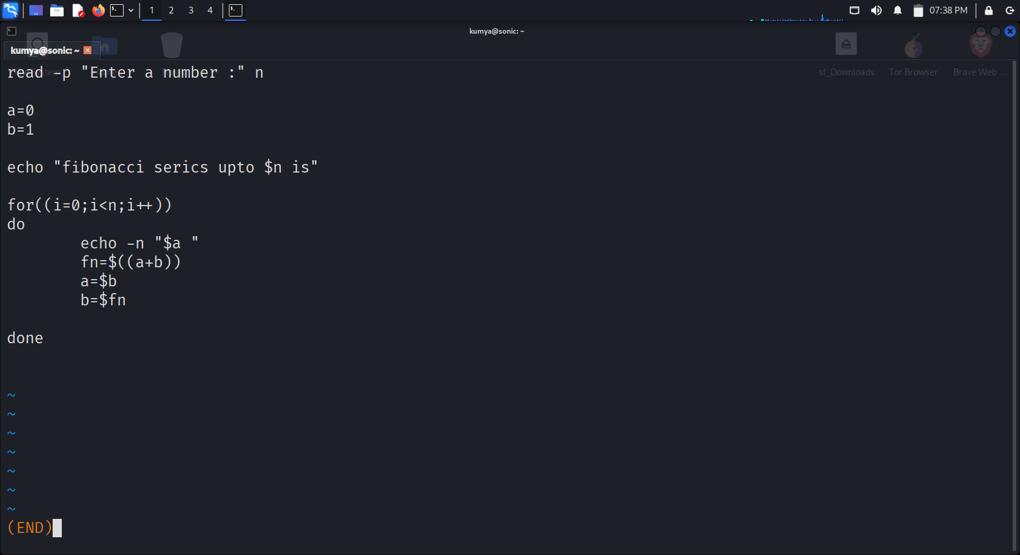

- Snapshot 2: Searching using /
User enters:
┌──(kumya㉿sonic)-[~]
└─$ /error
- Displaces the error word in the file …
- ...
Line 250: System Error: Disk not found
^ search match highlighted

- Snapshot 3: Scrolling
-- More (line 120/400) –

- Snapshot 4: Exiting
Press:
┌──(kumya㉿sonic)-[~]
└─$ q
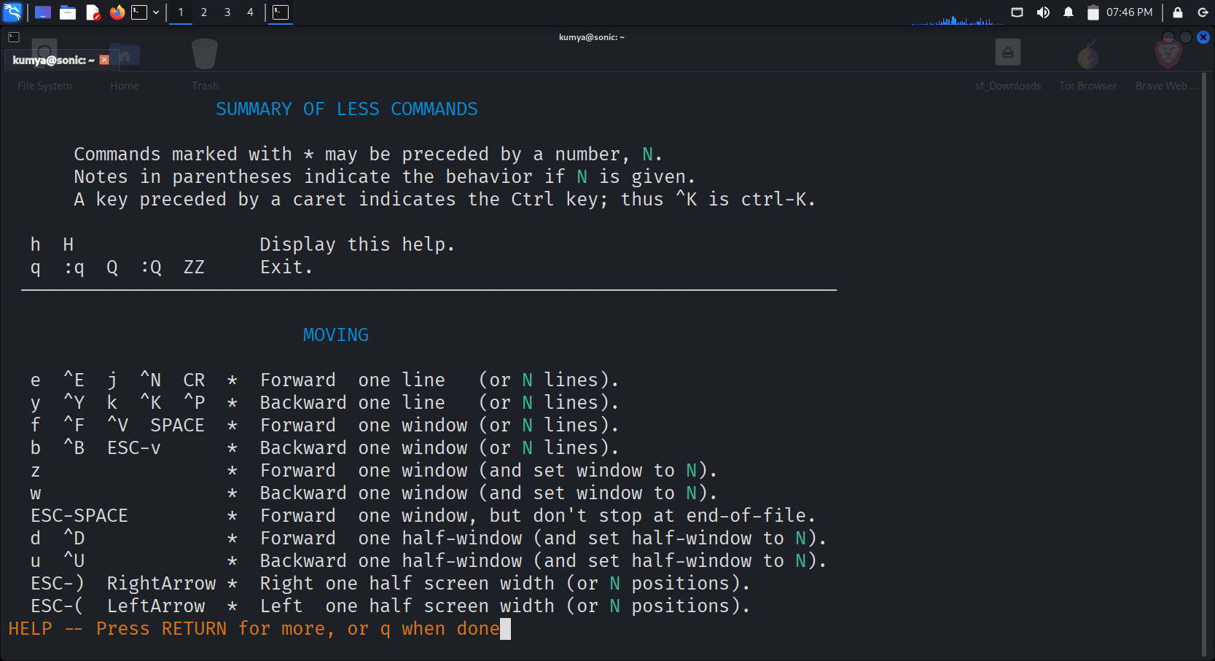

(5) Important Options & Flags of less (5–6 explained)
Below are the most commonly used and useful options.

1. -N → Show line numbers
┌──(kumya㉿sonic)-[~]
└─$ less -N myfile.txt
Displays each line with a line number.
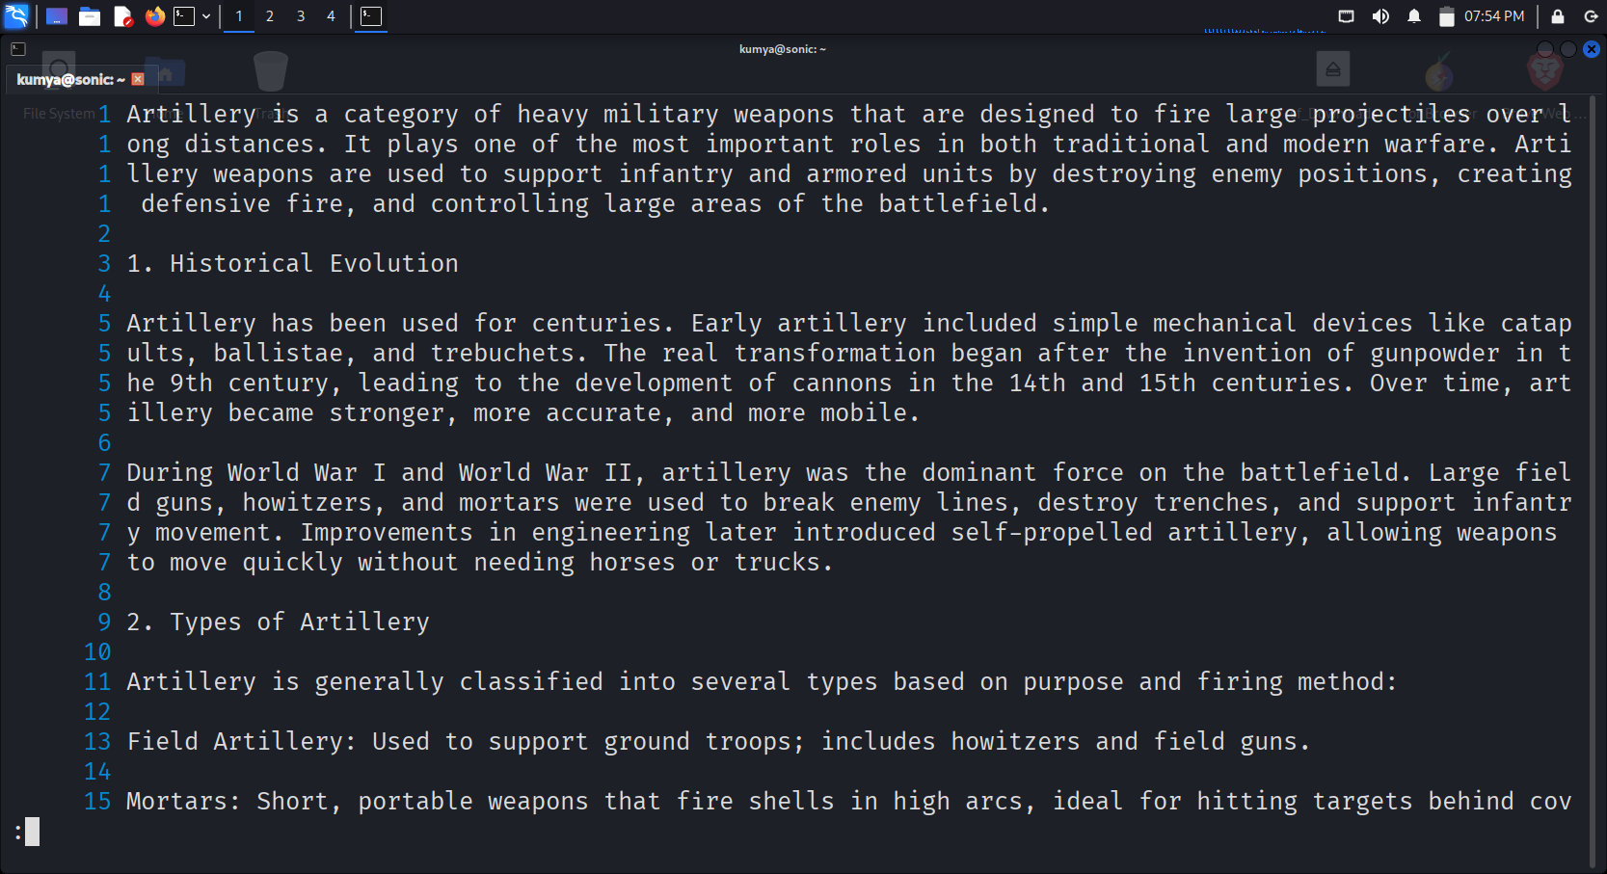

2. +F → Follow file (like tail -f)
┌──(kumya㉿sonic)-[~]
└─$ less +F /var/log/syslog
Live updates as new lines are added.

3. -i → Case-insensitive search
┌──(kumya㉿sonic)-[~]
└─$ less -i myfile.txt
Now /error will match ERROR, Error, etc.
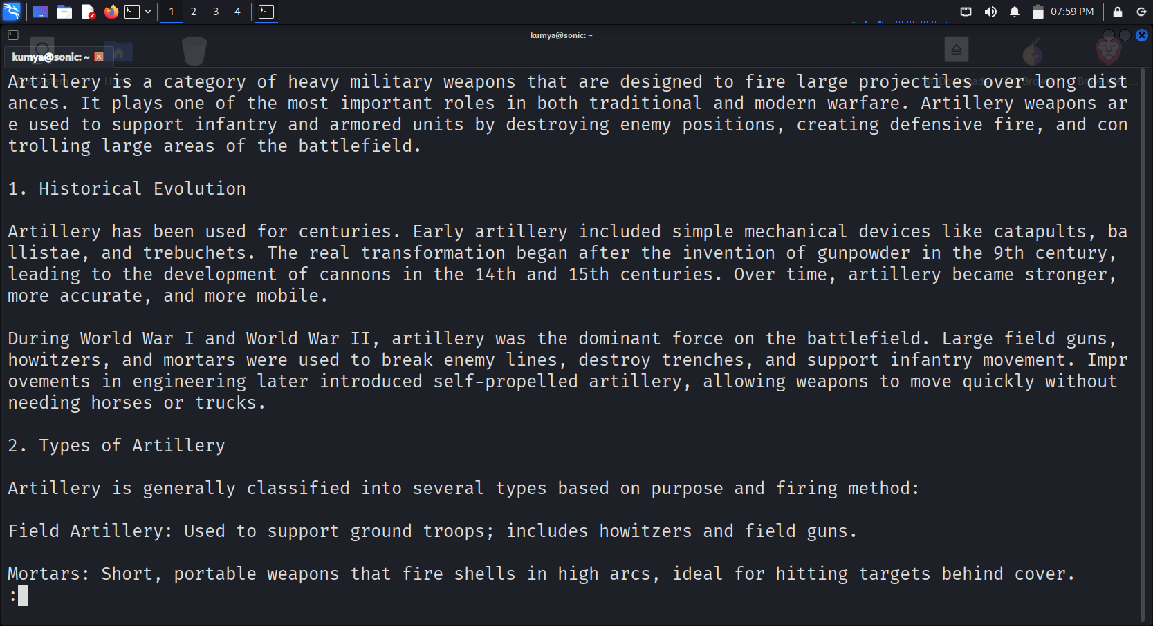

4. -S → Disable line wrapping
┌──(kumya㉿sonic)-[~]
└─$ less -S longfile.txt
Long lines will not wrap to the next line.
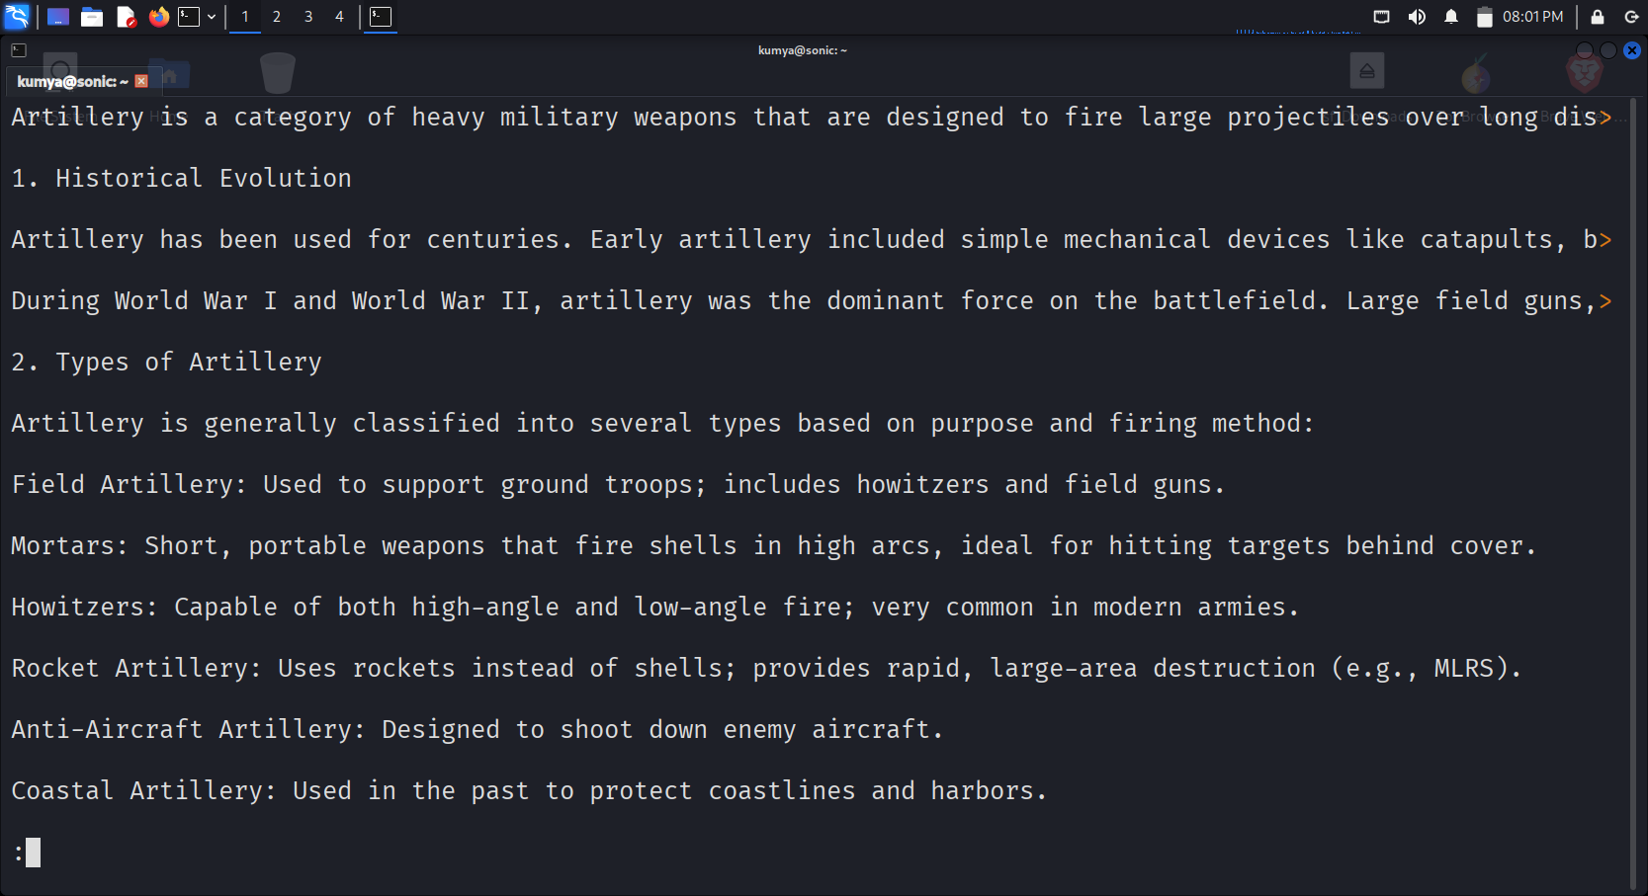

5. -p <pattern> → Start at first match of a pattern
┌──(kumya㉿sonic)-[~]
└─$ less -p ERROR log.txt
Directly jumps to the first occurrence of “ERROR”.

6. -R → Display color codes
Useful when viewing colored output files.
┌──(kumya㉿sonic)-[~]
└─$ less -R colored_output.txt

The less command is a powerful pager tool invented in 1983 by Mark Nudelman to improve on the limitations of the more command. It is widely used by system administrators because it provides efficient, scrollable, searchable access to large files without loading them fully into memory. With its powerful options, pattern search features, and smooth navigation, less remains one of the most essential commands in Linux/Unix environments.

================================+++++++++++==============================

- 2nd Command -> lsmem

(1) What is the lsmem command? (History, invention, author)
Definition
lsmem is a Linux command used to display detailed information about system memory layout, specifically memory blocks, online/offline status, and memory ranges.
History
- lsmem is part of the util-linux package, a large collection of essential Linux system utilities.
- Util-linux is maintained by Karel Zak and the Linux community.
- It was introduced around 2017 (util-linux v2.29) to provide better insights into memory block details, which older tools like free or top cannot show.
- The purpose of lsmem was to support memory hotplugging, NUMA systems, and virtualized environments.
Author
- Primary maintainer: Karel Zak
- Contributors: Linux Kernel developers and util-linux maintainers

(2) Why is lsmem useful for System Administrators?
System administrators often manage:
- Physical servers
- Virtual machines
- Cloud infrastructure
- NUMA nodes
- Hot-pluggable RAM
lsmem is extremely useful because it gives precise memory block information, not just the total RAM.
Usefulness
- Helps in memory troubleshooting
- Shows online/offline memory blocks
- Supports RAM hot-add / hot-remove analysis helps manage NUMA architecture
Gives memory range and block size, which is important for hardware-level maintenance
- Useful for virtual memory allocation in cloud and virtualization systems
In short, lsmem gives structural details about how RAM is organized inside the system—something no other basic tool shows.

(3) How does the lsmem command work? (with examples)
lsmem reads memory block details from:
/sys/devices/system/memory/
These entries tell the kernel how memory is divided into blocks, and whether each block is online or offline.
Basic Usage
┌──(kumya㉿sonic)-[~]
└─$ lsmem
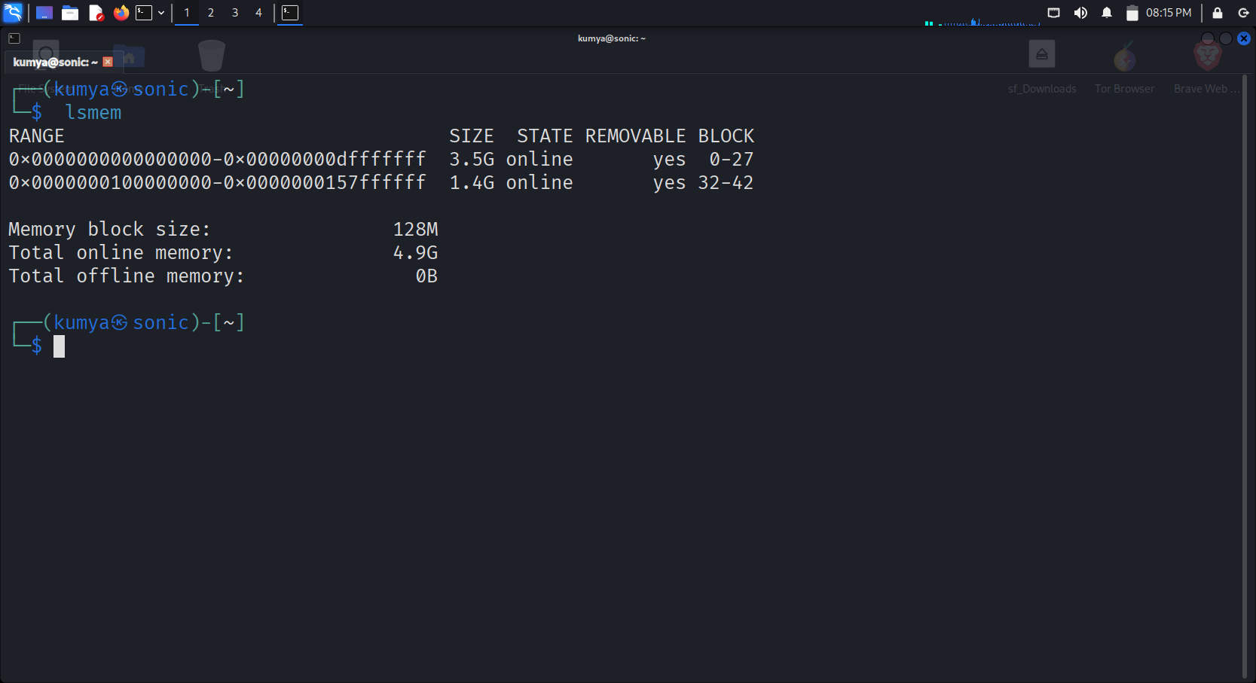
- Memory exists in blocks
- Blocks have a size (e.g., 128 MB)
- Some blocks may be offline (removed or unused)
Example 1: Show memory blocks with state
┌──(kumya㉿sonic)-[~]
└─$ lsmem –summary
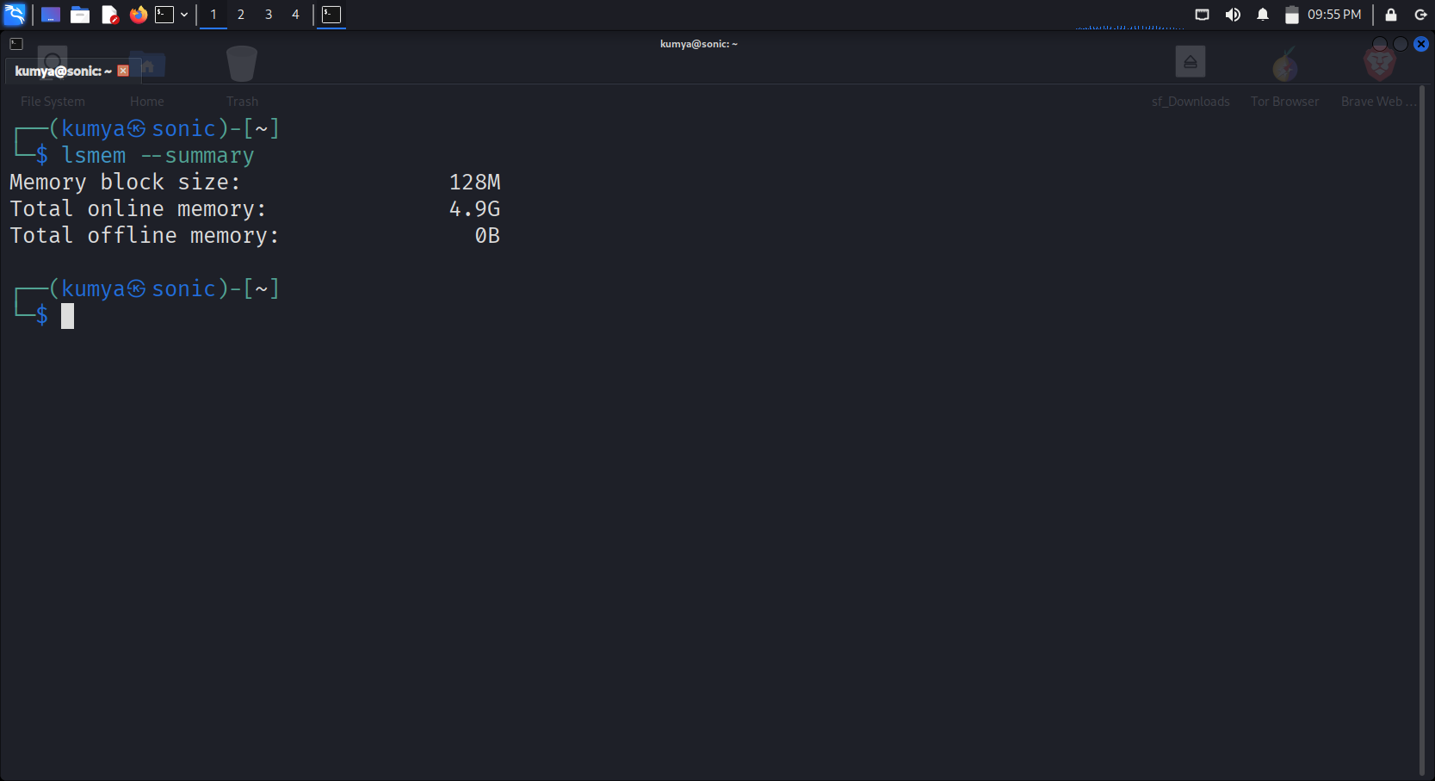

Example 2: Show only online memory
┌──(kumya㉿sonic)-[~]
└─$ lsmem --online
Example 3: Show memory in bytes
┌──(kumya㉿sonic)-[~]
└─$ lsmem –bytes
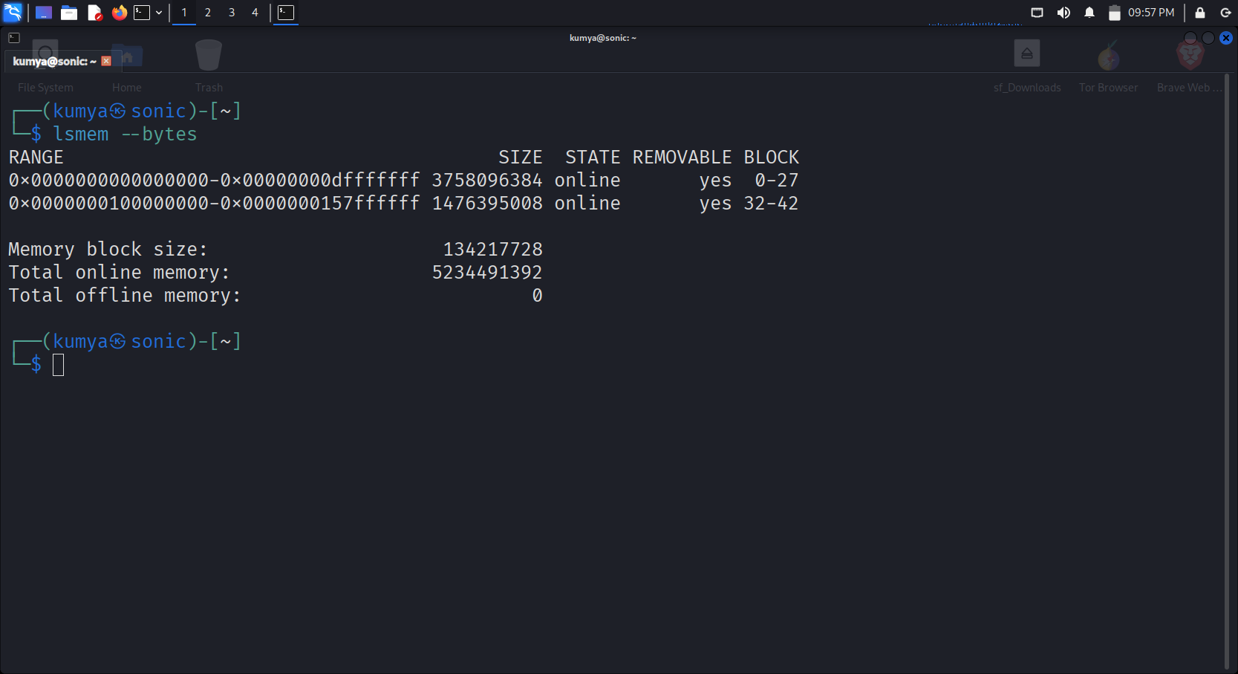

Example 4: Display output in human readable format
┌──(kumya㉿sonic)-[~]
└─$ lsmem -h
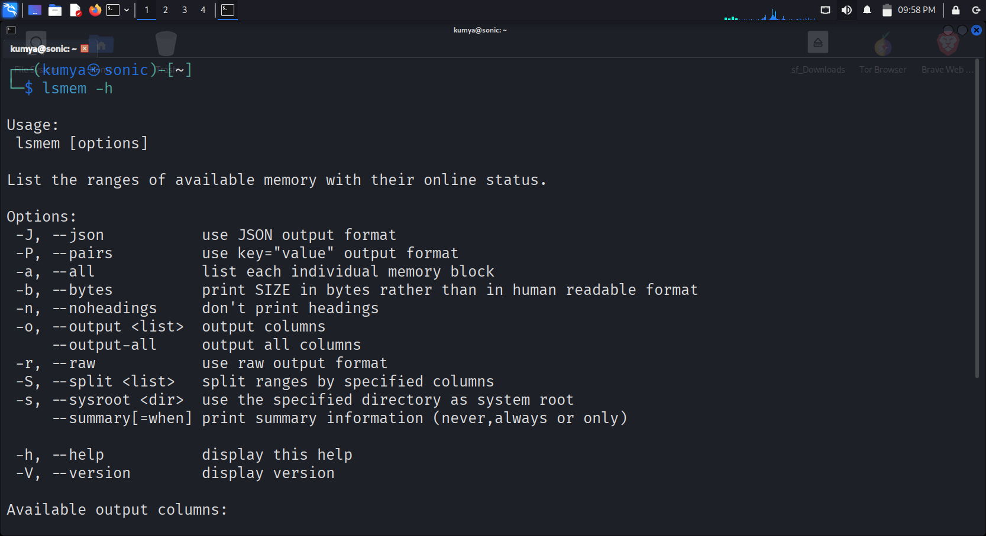

(4) Snapshots of command execution (text illustrations)
Below are assignment-friendly textual snapshots. You can convert them to images if needed.

- Snapshot 1: Basic lsmem output
┌──(kumya㉿sonic)-[~]
└─$ lsmem
RANGE SIZE STATE REMOVABLE
0x00000000-0x0009ffff 640K online no
0x00100000-0x7fffffff 2GB online yes
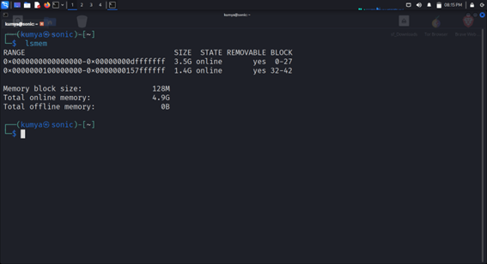
Memory block size: 128MB
Total online memory: 2.1G

- Snapshot 2: Show only online blocks
┌──(kumya㉿sonic)-[~]
└─$ lsmem --online
RANGE SIZE STATE
0x00000000-0x7fffffff 2GB online

- Snapshot 3: Summary output
┌──(kumya㉿sonic)-[~]
└─$ lsmem --summary
Memory block size: 128MB
Total online memory: 2GB
Total offline memory: 512MB
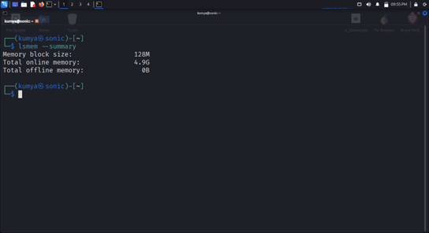
- Snapshot 4: Display in bytes
┌──(kumya㉿sonic)-[~]
└─$ lsmem --bytes
Memory block size: 134217728
Total online memory: 2147483648
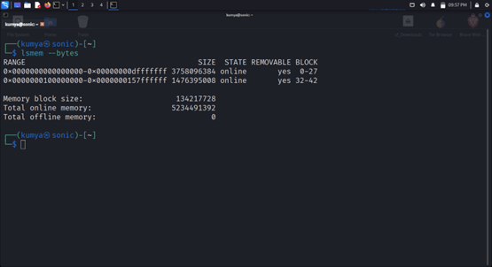

(5) Important Options / Flags of lsmem (5–6 explained)
Below are the essential flags:

1. ┌──(kumya㉿sonic)-[~]
└─$ --summary
Shows a summary of all memory blocks, including sizes and totals.
lsmem --summary

2. ┌──(kumya㉿sonic)-[~]
└─$ --online
Displays only memory blocks that are online.
lsmem --online
Useful when checking active memory on servers.

3. ┌──(kumya㉿sonic)-[~]
└─$ --offline
Shows offline (unused/hot-plugged) memory blocks.
lsmem --offline
Helps diagnose memory hotplug issues.

4. ┌──(kumya㉿sonic)-[~]
└─$ --bytes
Output values in bytes instead of MB/GB.
lsmem --bytes
Useful for scripting and precise calculations.

5. ┌──(kumya㉿sonic)-[~]
└─$ -o or --output
Customize the displayed columns.
lsmem -o RANGE,SIZE,REMOVABLE

6. ┌──(kumya㉿sonic)-[~]
└─$ --noheadings
Removes header line from output.
lsmem --noheadings
Useful for automation / scripting.

Conclusion (Assignment-Ready)
The lsmem command is a specialized Linux utility used to display detailed memory block structure information. Introduced through the util-linux package and maintained by Karel Zak, it is essential for system administrators working on virtualization, NUMA systems, physical servers, and memory hotplug environments. Its ability to show online/offline memory, block sizes, ranges, and summary information makes it an important tool for memory analysis and troubleshooting.

-------------------------------------------------------END-----------------------------------------------------

